Surname and Initials:  ……………………………………………………  Reyneke, R | Session Day:  …………………  9 April | Group No:  …….……..…  6
Student number: u21495034

DEPARTMENT OF PHYSICS
FSK 116
GRA 2
The theory for this practical can be found under the “Online Practicals” tab on clickUP. The graph rules can also be found there. Some graph sheets are included in this document.
Graph C - Fitting an exponential function to data
Quantities that increase or decrease exponentially are relatively common. The question is, how would one recognise it from a set of data and how would one set up the mathematical relationship between the variables? In this section, we intend to answer these questions.
The count rate of a radioactive sample was measured with a radiation detector over a period of seven hours. The data is displayed in Table 1. We intend to fit the data to the exponential function:
$R= R_{o}e^{-λt}$………(1)
where R0 and lambda are constants.
Table 1: The decreasing activity of a radioactive sample.
Time, t (hours) | Count Rate, R (counts/s)
1.0 | 4803
2.0 | 3010
3.0 | 1890
4.0 | 1233
5.0 | 754
6.0 | 472
7.0 | 319

1. Draw a graph of the count rate, R, of the sample as a function of time, t. Try and draw a smooth curve through the data points. How can you tell if the relationship is linear or not?
(NOTE: Use the graph paper provided on the next page)
2. Make a new table with x-values, the time, in hours and the y-values, the natural logarithm (that is the logarithm to the base e) of the count rate values.
Time, t (hours) | ln(R) (counts/s)
1.0 | 8,48
2.0 | 8
3.0 | 7,54
4.0 | 7,1
5.0 | 6,63
6.0 | 6,16
7.0 | 5,77

3. Draw a graph of this new set of values (insert it on the next page). It should be linear if the original data can be represented by an exponential function. Note that one would also obtain a linear function if the data were to be plotted on a semi-logarithmic graph paper. The fact that the second graph is linear confirms our suspicion that you can fit an exponential function to the data.
(NOTE: Use the graph paper provided on the next page)
4. Explain how you know that there is a linear relationship between the natural logarithm ln(R) and time, t, values. Determine the y-intercept, y₀ , and the slope, α, of the graph. You need to choose arbitrary points 1 and 2 (not data points!) for the slope as far apart as possible on the graph. Show your full calculations and values.

5. Write down the linear relationship between the ln(R) and t values and substitute the constant values you found for the y-intercept and slope into the linear equation. Display the units, if any, of the inserted constants.

6. Show that
ln(R) = ln(R₀ ) + (-λ)t ………(2)
by taking the natural logarithms on both sides of equation 1. Compare this equation to your empirical equation in question 5. Explain why y₀ = ln(R₀ ) and α = -λ. Use this information to determine the corresponding values, and units, for R₀ and λ.

7. Write equation 1 down again with the corresponding values, and units, for the constants in the equation. This is the exponential function for the data.

8. At this point you can say that the radioactive sample is decaying exponentially according to equation 1. Explain what the meaning of the half-life, $T_{1/2}$ , of this process is.

9. Next use equation 1 to show that the relationship between the half-life and the decay constant, , is
${\ln\left(2\right)=λ T}_{1/2}$ ………(3)

10. Calculate the value of the half-life, $T_{1/2}$, using equation 3. Include the units for the half-life.

NB: For the following section ONLY (Graph D), you may use excel, graphing software, blank paper, or the graph paper provided at the end to plot the graphs. (NOT applicable to Graph C)

Graph D – Exercise: Simulation of Nuclear Decay
Background theory
The phenomenon of exponential decay occurs in several areas of Physics, and is characterized by a direct proportional relationship between the quantity that decays, $N$, and the rate at which the quantity decreases, $\frac{ΔN}{Δt}$ :
$N ∝\frac{ΔN}{Δt}.$
This proportionality then implies the following relationship:
$N=-γ\frac{ΔN}{Δt},$
where $γ$ is a positive quantity known as the decay constant. It characterizes the rate at which the quantity decays. Larger values of 𝛾 signify a larger rate of decay. The negative sign implies that the quantity, $N$ is decreasing. If the quantity was growing, it would be positive.
Quantities that undergo exponential decay are described mathematically by an exponential function of time, which gives the quantity $N$ at a time, $t$:
$N\left(t\right)=N_{0}e^{-γt}.$ (1)

At some initial time $t=0,$
$N\left(0\right)=N_{0}e^{-γ(0)}=N_{0}.$ (2)
So the $N_{0}$ is the initial value of the quantity, $N$. For a system of radioactive particles, $N_{0}$ is the initial number of particles that have not yet decayed.
If the graph of $N$ versus $t$ is plotted, the following exponential curve is obtained:
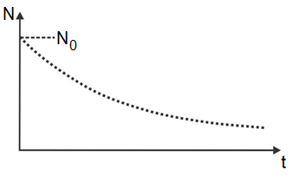
To determine the decay constant for a specific process, a linear relationship must be derived from
equation (1).
Experiment
AIM: Simulate a system of particles undergoing radioactive decay and determine the half-life of this system.
Experimental apparatus:
- Twenty identical coins. The 5c coin is of the smallest value and works well, but 10c, 20c, 50c, R1, R2 or R5 coins are also fine. If you do not have identical coins, ask a shopkeeper to give you twenty 5c coins in exchange for a R1 coin.
- A container with a lid. A tupperware box works well, but a pot or shoebox with no holes is also fine.
Experimental procedure:
- Take a look at the coins. One side has the South African shield on it, and one side has a plant/animal on it.

Plant/animal
Shield
- Choose a well-lit room in your home. Put the coins in the container, so that all the coins have the side with the animal/plant facing up. In other words, no shields should be visible. These coins represent radioactive particles that have not yet decayed.
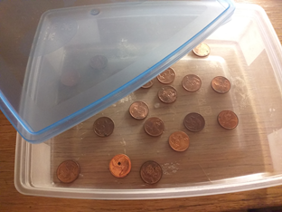
- Place the lid on the container and hold it firmly shut. Shake the container vigorously for about 10 seconds. This shaking of the container that causes some coins to flip over represents the passing of time.
- Open the container. Remove all the coins that landed shield-side up. These “particles” have “decayed”. Count the remaining coins which are plant\animal-side up. Make a note of the number of coins still plant\animal-side up.
- Put the lid on again, and shake again. Open the lid and remove the coins that landed shield-side up. Count the remaining coins, and make a note of the number.
- Repeat the previous step until only about one coin is still plant\animal-side up, or “radioactive”.
- After conducting the experiment once, repeat all steps 1-6 again to obtain a second set of data.
- Show your experimental setup (take a picture of your experimental setup)

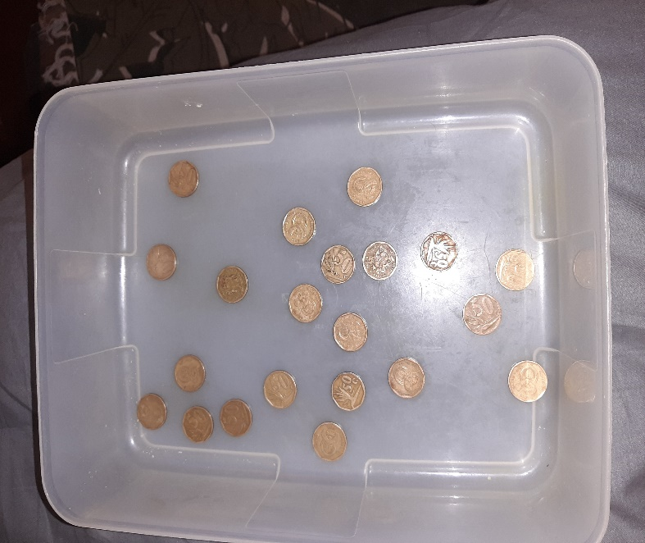
- Tabulate your results in the given table:
Table 1
Title: Data obtained by simulating a system of particles undergoing radioactive decay to determine the half-life of this system.

Number of radioactive particles, N for  1st time experiment  is done | Number of radioactive particles, N for  2nd time experiment  is done | Number of times container was shaken, or time, t in units of “shakes”
20 | 20 | 0
11 | 12 | 1
8 | 7 | 2
4 | 5 | 3
1 | 4 | 4
0 | 2 | 5
0 | 0 | 6

- Using the blank graph paper given on the last page OR graphing software such as Excel OR separate graph paper OR blank paper, draw two separate graphs of $N$ versus t for the two sets of data from Table 1. Place the two graphs here.

- Using these graphs of $N$ versus $t$, determine the value of the half-life, $T_{1/2}$, off the graphs. Indicate on the graphs which points you used to determine $T_{1/2}$ by drawing dotted lines. Calculate the average of the two half-lives.

- To accurately determine whether this process really represents exponential decay, the data must be linearized and plotted. Complete the following table, using the data from Table 1:
Table 2
Title:

$\ln{N}$  for 1st time experiment  was done | $$\ln{N}$$for 2nd time experiment  was done | t (shakes)
3 | 3 | 0
2,4 | 2,5 | 1
2,1 | 1,95 | 2
1,4 | 1,61 | 3
0 | 1,39 | 4
 | 0,7 | 5
 |  | 6

- Using the blank graph paper given on the last page OR graphing software such as Excel OR separate graph paper OR blank paper, draw two separate graphs of $\ln{N}$ versus t for the two sets of data from Table 2. Place the two graphs here.

- Determine the gradient of both graphs and determine the decay constant, γ for both experiments. Calculate the average of the two values.

- Using the average decay constant, γ, determine the half-life, $T_{1/2}$, of the system.
[HINT: use Equation 3 from question 9 of the previous section (Graph C) ]

Summary
For an exponential relationship between the variables, we obtain a linear graph on normal graph paper if we plot the natural logarithm of the dependent values versus the independent values. An exponential function also produces a straight-line graph if it is drawn on semi-logarithmic graph paper.

